PROJECT REPORT
ToyCraft Tales: Tableau's Vision into Toy Manufacturer Data

INTRODUCTION

Project Overview
"ToyCraft Tales" is a data visualization project developed using Tableau to explore the toy manufacturing industry. It aims to uncover insights into market trends, consumer preferences, and regional demand using interactive dashboards based on historical and survey data.

Purpose
The purpose of this project is to provide toy manufacturers, educators, and retail decision-makers with an intuitive platform that helps them understand toy sales behaviour over time and geography. The dashboard supports data- driven planning, inventory control, and customer satisfaction.

IDEATION PHASE

Problem Statement
Toy manufacturers struggle with understanding consumer preferences, seasonal trends, and regional toy demands. They need a data-driven dashboard to align production and distribution with real-world insights.

Empathy Map Canvas
- Who are we empathizing with? Toy manufacturers, retailers, parents
- What do they need to do? Understand toy trends and consumer demands
- What do they see? Fragmented reports or guess-based decisions
- What do they say/do? Rely on past experience or basic trends

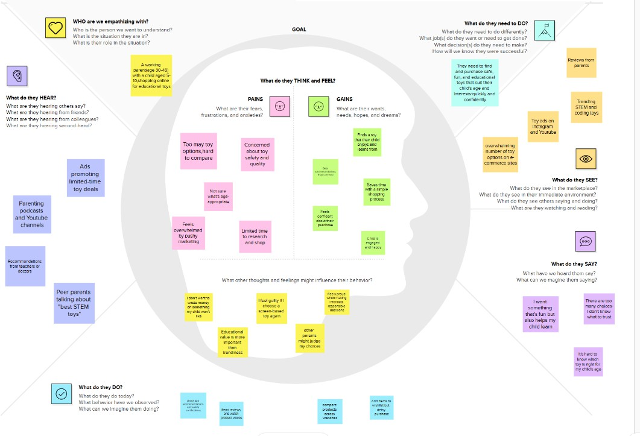
- What do they hear? Market pressure, retailer feedback, competitor movements

Brainstorming Participants & Ideas:
    - Student 1: Integrate real-time feedback, Include demographic filters, Create exportable graphs
    - Student 2: Use survey forms, Allow interactive maps, Add toy type comparison
    - Student 3: Monthly sales heatmap, Top toys by region, Historical vs current analysis
    - Student 4: Holiday sales tracker, Toy category popularity, Personalized insights
Grouped Ideas: Dashboard Filters, Visual Comparison Tools, Real-time Feedback Integration, Personalization, Export Options

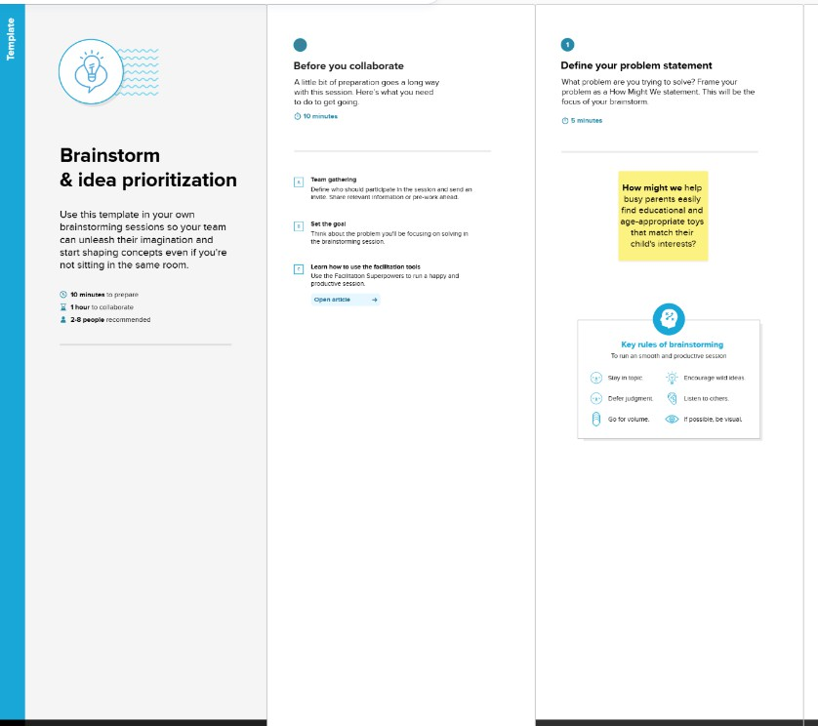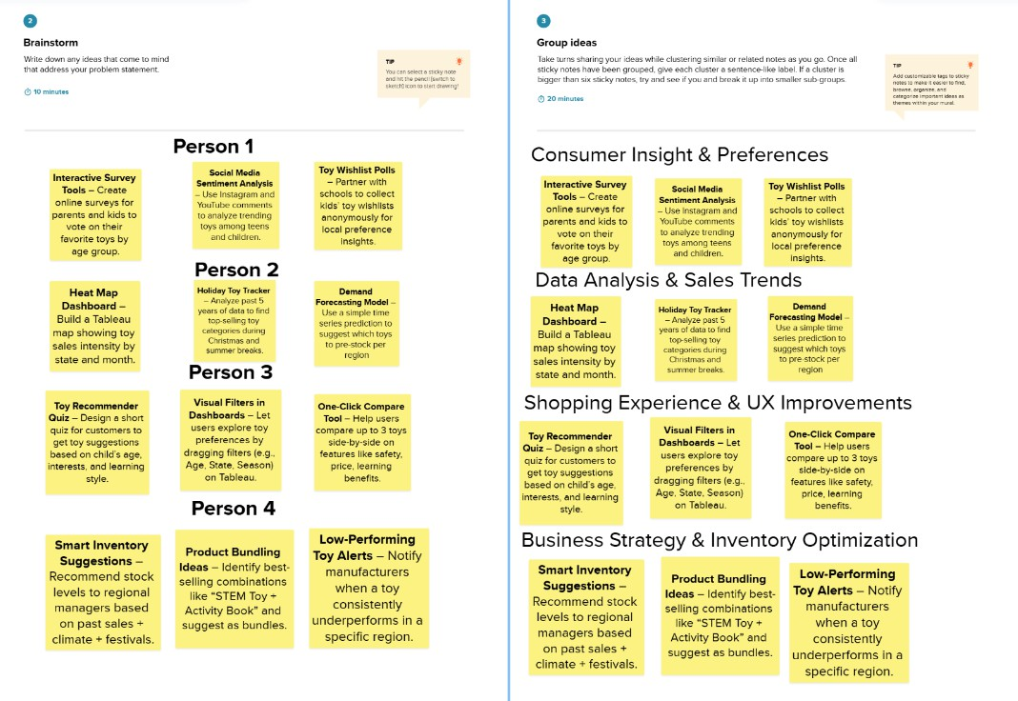

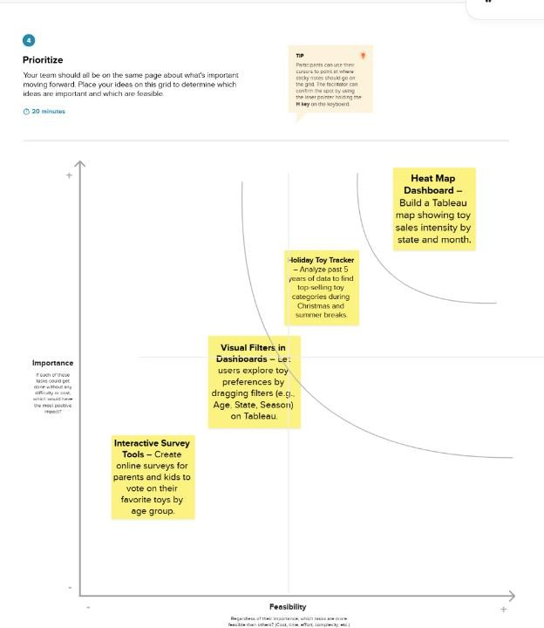

REQUIREMENT ANALYSIS

Customer Journey Map
Experience Steps include: Entice > Enter > Engage > Exit > Extend. Touchpoints include registration, dashboard use, export, and re-engagement via emails.

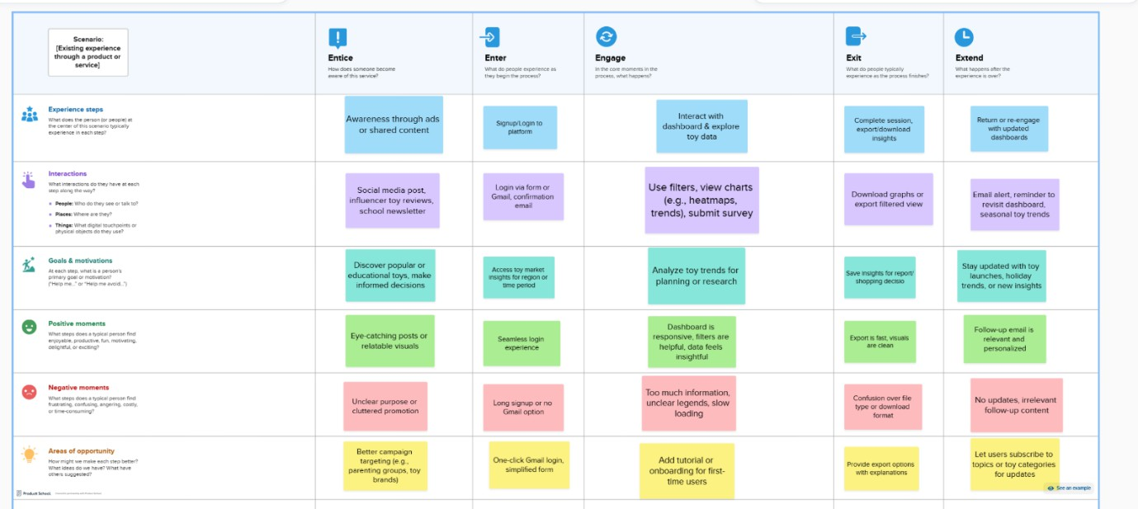

Solution Requirement
    - Functional: User registration, Dashboard filtering, Survey form submission, Data visualization, Download graphs
    - Non-Functional: Usability, Scalability, Security, Performance, Accessibility

Data Flow Diagram
    - User > Form input > Data preprocessing (Excel/Tableau Prep) > Tableau dashboard > Filters & Visualizations > Export/Feedback

Technology Stack
    - Frontend: Tableau
    - Backend/Data: Excel, Tableau Prep, Google Forms
    - Hosting: Tableau Public

PROJECT DESIGN

Problem Solution Fit
Connects the customer need for insights with a visual solution. Provides data clarity for better planning.

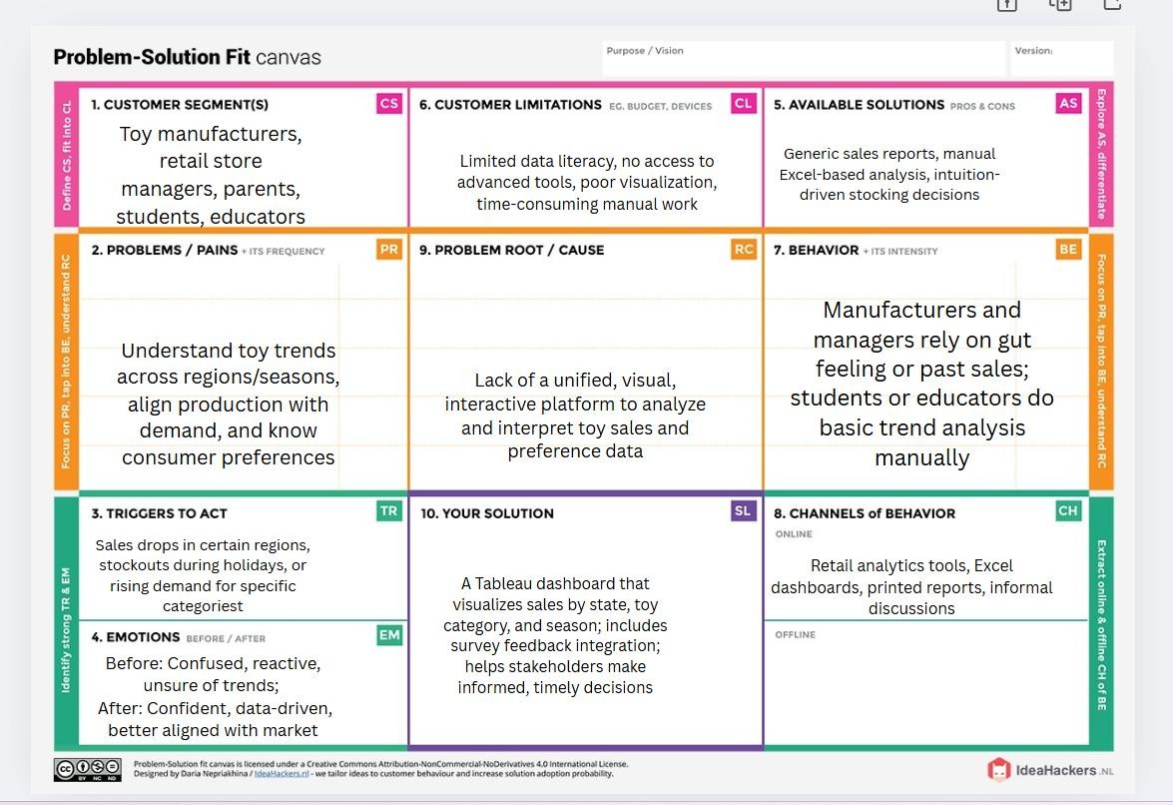

Proposed Solution
An interactive Tableau dashboard that visualizes toy sales data filtered by region, category, and season with integrated survey feedback for trend alignment.

Solution Architecture
User input & dataset → Tableau Prep → Processed dataset → Tableau Dashboard → Filter, visualize, and export features

PROJECT PLANNING & SCHEDULING

Project Planning
Sprints:
    - Sprint 1: Registration & Login (5 story points)
    - Sprint 2: Dashboard creation & filtering (6 story points)
    - Sprint 3: Survey integration & export (6 story points)
    - Sprint 4: Admin control & final testing (3 story points)

Tools Used:
- Mural – For brainstorming, empathy maps, and idea prioritization
- Excel/Google Sheets – For data cleaning and backlog tracking
- Tableau Public – For building dashboards, stories, and sharing
- Draw.io / Diagrams.net – For DFDs and visual planning
- MS Word / PDF Editor – For writing and formatting the final report

FUNCTIONAL AND PERFORMANCE TESTING

Performance Testing

DataRendered:
The dashboard uses toy manufacturer data from the years 2000 to 2022, covering long-term trends.

Preprocessing:
Before importing into Tableau, the data was cleaned to remove missing values, correctly format dates, and standardize state names to ensure accurate visualization.

FiltersUsed:
Users can explore the data using several interactive filters like:
➤Year (to view trends over time)
➤State (to analyze region-wise distribution)

➤Toy type (to check category-wise sales)
➤ Season (to understand seasonal patterns)

CalculationFields:
Custom fields were created inside Tableau to enhance analysis, such as:
➤ % Growth (year-on-year increase in sales)
➤ Category Rank (ranking of toy types based on demand)
➤ Sales by Region (total units sold by state/region)

DashboardDesign:
A total of 6 visualizations were created using different chart types including:
      - Line Chart, Bar Chart, Heatmap, Treemap, Pie Chart, and Dual-Axis Chart

StoryDesign:
The data was also structured as a Tableau Story with 5 slides/pages, each explaining a part of the data:
- Intro
- Market Trends
- Seasonal Insights
- Regional Distribution
- Customer Preferences

RESULTS

Output Screenshots
DASHBOARD

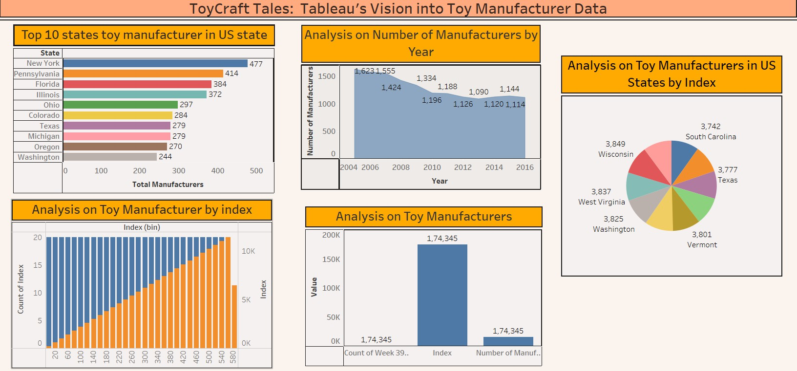

ADVANTAGES & DISADVANTAGES

Advantages
- Easy to Use: Anyone, including students and business users, can explore the data.
- Effective Filters: Quick insights using Year, Region, Season, etc.
- Live Survey Integration: Customer feedback can be visualized in real time.

Disadvantages
- Limited Dataset: Depends on what’s available publicly or collected manually.
- Feature Limits in Free Version: Tableau Public restricts some sharing and interactivity features (compared to Tableau Server).

CONCLUSION
The ToyCraft Tales dashboard effectively visualizes toy industry data to support better decisions in manufacturing, marketing, and distribution. It simplifies complex data and presents it in a clear and actionable format, helping bridge the gap between raw data and strategy.

FUTURE SCOPE
- AI-Based Trend Prediction: Forecast future toy trends using machine learning.
- Demographic Filters: Include age, gender, and urban/rural segmentation.
- Mobile Compatibility: Make dashboards easier to use on smartphones/tablets.
- Inventory Integration: Connect with real-time inventory systems (ERP) for smarter stocking decisions.

APPENDIX

Dataset Link:
https://www.kaggle.com/datasets/thedevastator/toy-manufacturers-in-us- states?select=Week+39+-+US+Toy+Manufacturers+-+2005+to+2016.hyper

GitHub Link:
https://github.com/kaithepalliindu/ToyCraft-Tales-Tableau-s-Vision-into-Toy-Manufacturer-Data

